***Big Mountain Resort: Ticket Price Analysis***

Big Mountain Resort currently charges $81 for their ticket prices. We are trying to increase the ticket price of this resort. Various data analyses have been done, and various correlations between ticket prices and the resort’s features have been found. We used the Random Forest Model and found the top four dominant features:

1. fastQuads
2. Runs
3. Snow Making_ac
4. vertical_drop

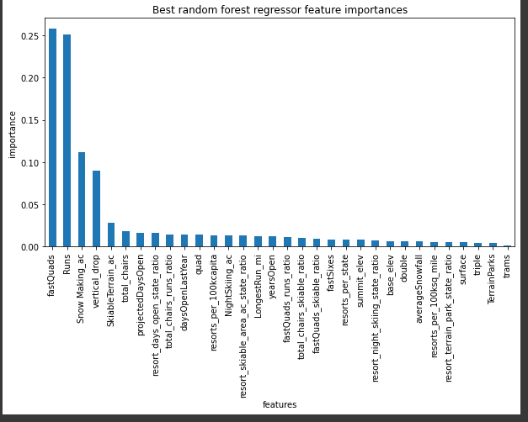

Using the Random Forest Model we calculated the expected ticket price for Big Mountain. The modeled price is 94.22 with the mean absolute error of 10.39, this suggests that there is room for an increase.

Also, we compared the important features of Big Mountain with other resorts. The Big Mountain resort’s features like vertical drop, snow-making area, the total number of chairs fast quads runs, longest runs, trams, skiable train area are on the top of the league charts of facilities offered.

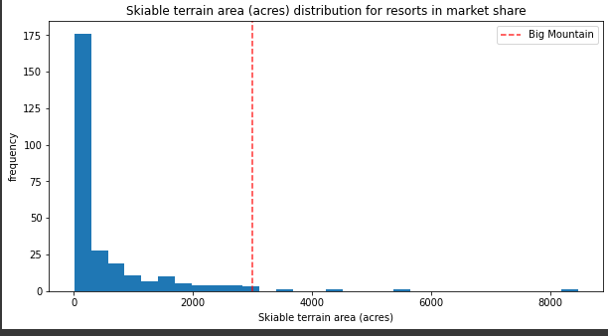

**The business has shortlisted some options:**

Permanently closing down up to 10 of the least used runs. This doesn't impact any other resort statistics.

Increase the vertical drop by adding a run to a point 150 feet lower down but requiring the installation of an additional chair lift to bring skiers back up, without additional snowmaking coverage

Same as number 2, but adding 2 acres of snowmaking cover

Increase the longest run by 0.2 miles to boast 3.5 miles length, requiring additional snowmaking coverage of 4 acres

**Findings:**

The model says closing one run makes no difference. Closing 2 and 3 successively reduces support for ticket price and so revenue. If Big Mountain closes down 3 runs, it seems they may as well close down 4 or 5 as there's no further loss in the ticket price. Increasing the closures down to 6 or more leads to a large drop. Similarly, increasing a vertical drop, installing an additional chair lift will increase the ticket price by $1.99 and increase the revenue to $3474638 but could increase the operating cost of the additional chair. Adding 2 acres of snowmaking makes no difference in price. The good suggestion for this resort will be closing down the 1 runs because it does not have any negative impact on prices but can save operating costs.